

Software Engineering Project Indusekhar Ravilla, Firmino M. Mucucete

Abdoul Kassim Sogore.

Testing Plan

**Deliverable:** TP

**Title:** Testing Plan

**Authors:** Indusekhar Ravilla, Firmino M. Mucucete, Abdoul Kassim Sogore

**Version:** 1.0

**Date:** 25-June-2020

**Copyright:** Copyrights 2020, Indusekhar Ravilla, Firmino M. Mucucete

Abdoul Kassim Sogore– All rights reserved

# Table of Contents

1. Purpose
2. User Who is not Registered
   1. Visualization of The Web App
   2. Registration
3. Registered user
   1. Login
   2. Insert Data
   3. Create New Post
   4. Update and Delete of a Post
   5. Displaying Statistical Information and Map View
4. Conclusion
5. **Purpose:** The Purpose of the Test Plan Document is to Test and Verify All the Use Cases of the system and to make sure that everything is working fine so that when the App is released it works properly without any Errors arising.

# 2. User who is not registered

## 2.1 Visualization of The Web App

Table1.1 Testing of Home page section

|  |  |
| --- | --- |
| Name/Action | Enter to see the home page of website |
| Import/Input | <http://127.0.0.1:5000> |
| Initial state | Home page |
| Export/Output | Available to see Web App home page |
| Test Result | SUCCESS (Web App is Visible) |

## 

## 2.2 Registration

|  |  |
| --- | --- |
| Name/Action | Click table to Enter Username and Password |
| Import/Input | Characters of Name/Action |
| Initial state | Null |
| Export/Output | The User enters his desired Username in the username Box and Password in the Password Box to register himself into the web app |
| Errors | If the Username already exist, the Web app shows “User is already Registered” |
| Test Result | SUCCESS |

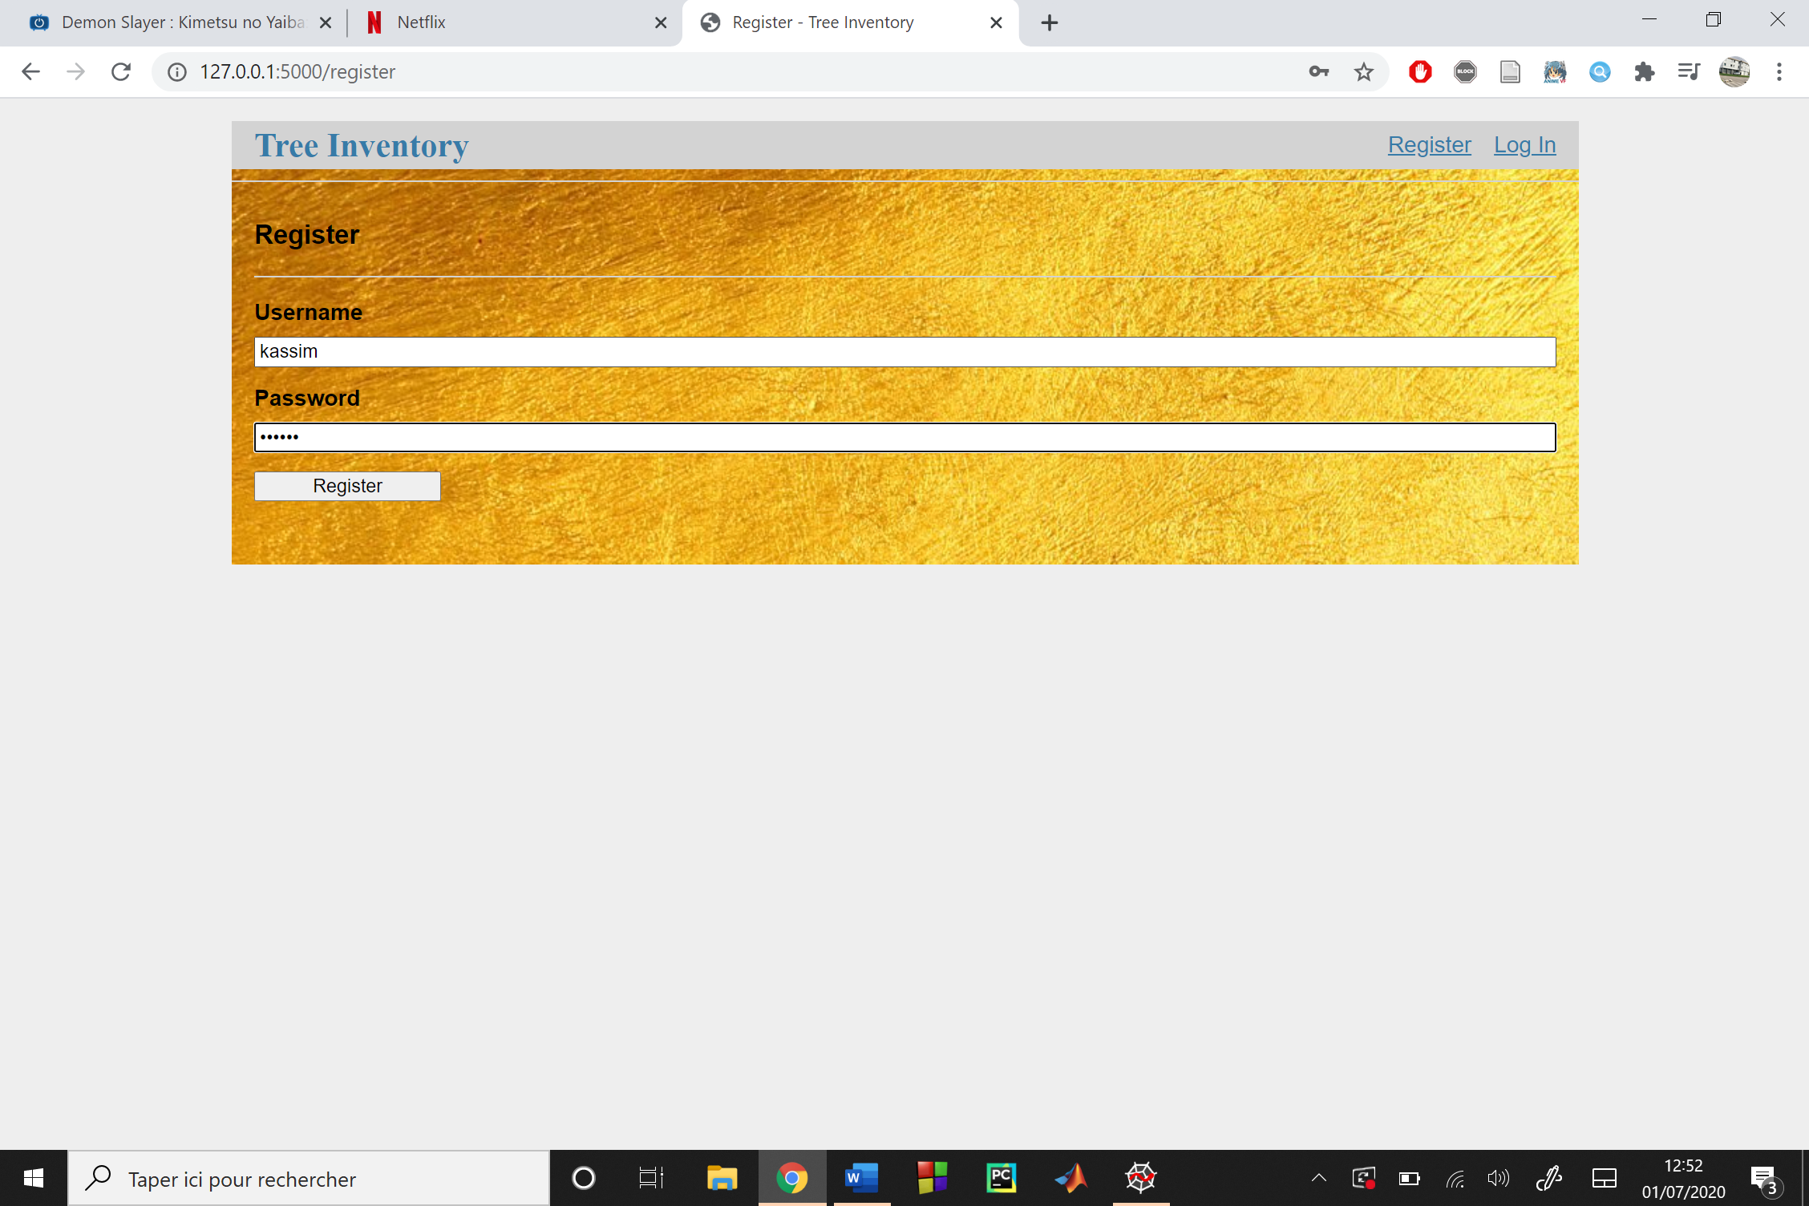

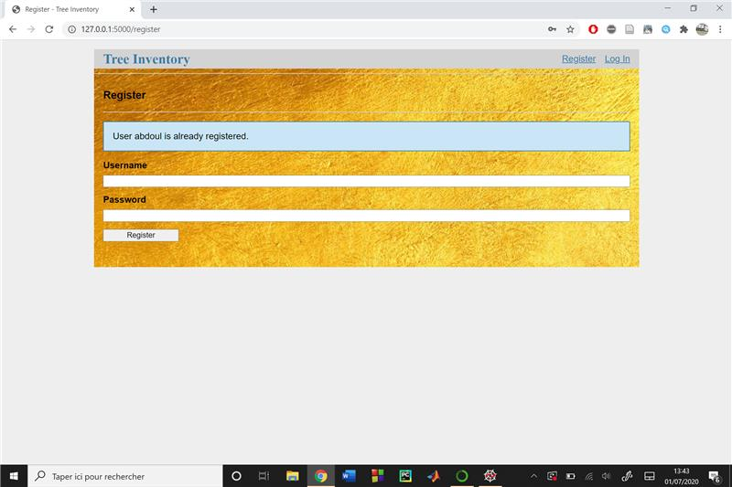

# 3 Registered user

## 3.1 Login

|  |  |
| --- | --- |
| Name/Action | Click “login” to Login to Web App |
| Import/Input | User Name And Password |
| Initial state | Null |
| Export/output | User Enter his Username and Password and clicks login to enter user home page |
| Errors | If either the user name or password is wrong the Web app shows Incorrect username or incorrect password corresponding to the data |
| Test Result | SUCCESS |
|  |  |

## 

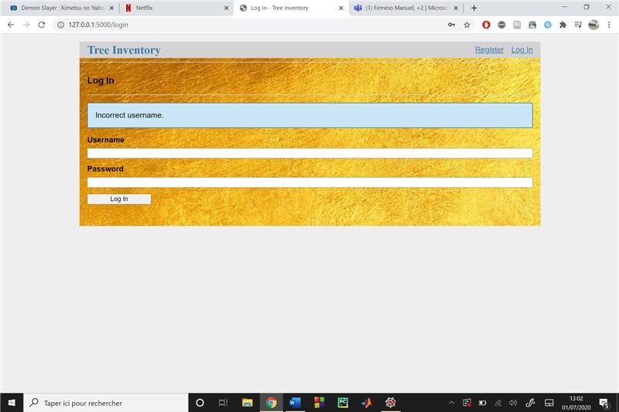

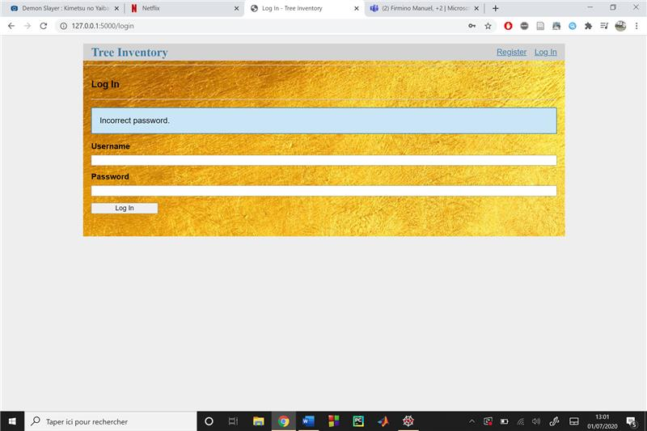

## 3.2 Insert Data

|  |  |
| --- | --- |
| Name/Action | Click “Insert Data” in the user home page bar |
| Import/Input | Null |
| Initial state | Home page |
| Export/Output | Jump to “Insert Data” section |
| Pre-Condition | User should be logged in |
| Error | If the Data Fields are empty the Web app shows “Please Complete this Field” |
| Test Result | SUCCESS |

## 

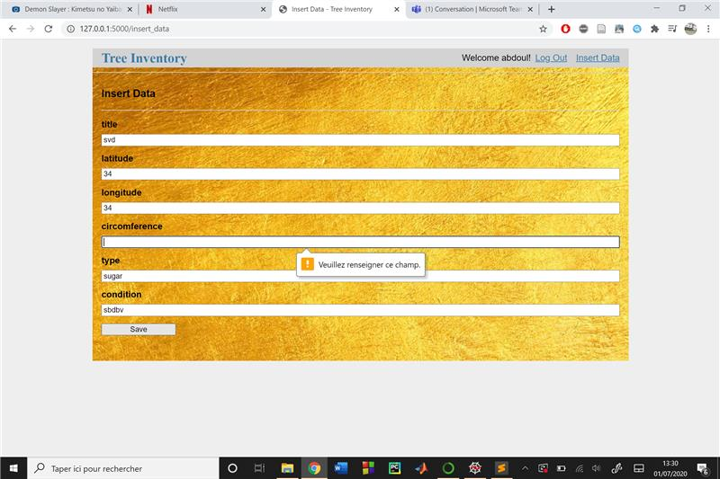

## 3.3 Create New Post

|  |  |
| --- | --- |
| Name/Action | User Clicks on the “Create New Post” to post his comments |
| Import/Input | Null |
| Initial state | Home Page |
| Export/Output | Jump to Create New Post Section Containing the fields allowing the users to inert their comments |
| Pre-Condition | User should be Logged in |
| Errors | The Web app shows “Only Logged in Users can Insert Posts” if the user is not Logged in by redirecting to the login page. |
| Test Result | SUCCESS |

## 

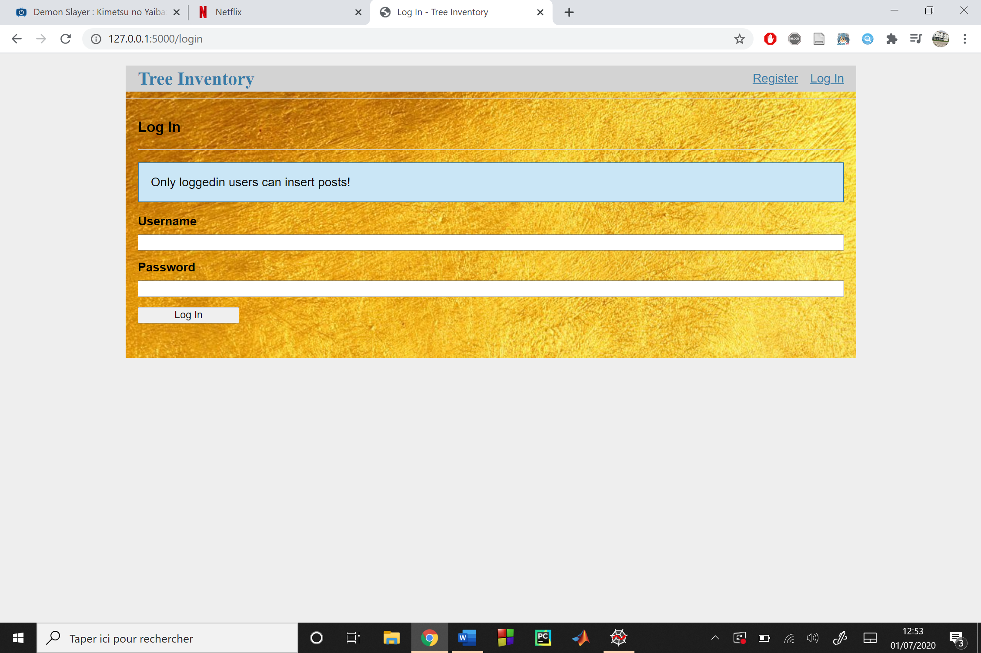

## 3.4 Update and Delete of a Post

|  |  |
| --- | --- |
| Name/Action | Update post or Delete Post |
| Import/Input | Click user’s post |
| Initial state | Blog Page |
| Export/Output | Jump to user’s own page with the selected post open in the Editor containing “Save” in grey and “Delete” in red. |
| Pre-Condition | User Should be Logged in  The user should have posted the comment. |
| Test Result | SUCCESS |

## 

## 3.5 Displaying statistical information and Map view

|  |  |
| --- | --- |
| Name/Action | Viewing the Data |
| Import/Input | User clicks on the links available on his home page |
| Initial state | Home page |
| Export/Output | Show Data in interactive way with respect to the view selected by the user |
| Test Result | SUCCESS |

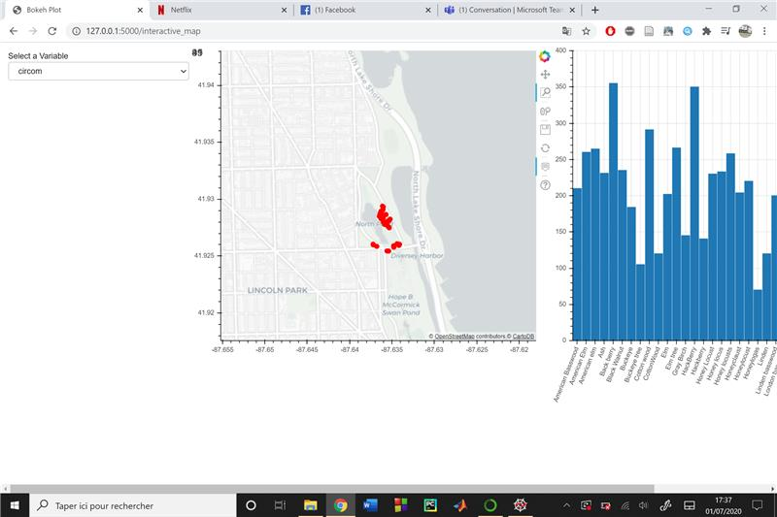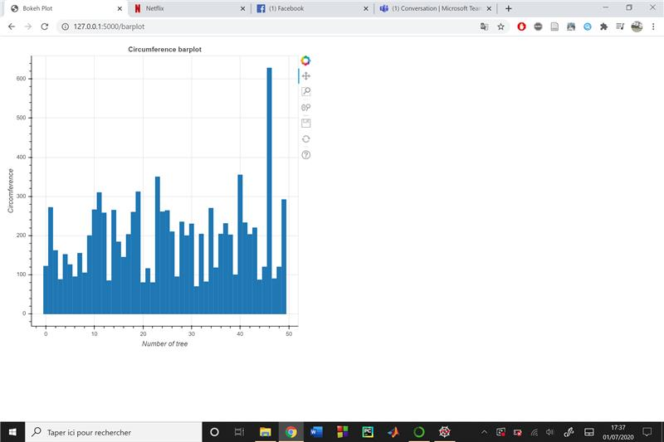

1. Conclusion: All the Defined Use Cases of the Web App are functioning Properly without any errors.